**MAT188 Assignment # 6 - Table 1 - Matrix Expressions**

|  |  |  |  |  |  |  |  |
| --- | --- | --- | --- | --- | --- | --- | --- |
| Where A = | 3 | 1 | 3 | B = | 1 | 1 | 1 |
|  | 1 | 2 | 1 |  | 2 | 2 | 2 |
|  | 3 | 4 | 1 |  | 3 | 3 | 3 |

|  |  |
| --- | --- |
| **Expression** | **Result** |
| A./B | |  |  |  | | --- | --- | --- | | 3.000 | 1.0000 | 3.0000 | | 0.5000 | 1.0000 | 0.5000 | | 1.0000 | 1.3333 | 0.3333 | |
| A.*B | |  |  |  | | --- | --- | --- | | 3 | 1 | 3 | | 2 | 4 | 2 | | 9 | 12 | 3 | |
| A.^2 | |  |  |  | | --- | --- | --- | | 9 | 1 | 9 | | 1 | 4 | 1 | | 9 | 16 | 1 | |
| rank(A) | 3 |
| rank(B) | 1 |

**MAT188 Assignment # 6 - Bacteria Growth and Interpretation**

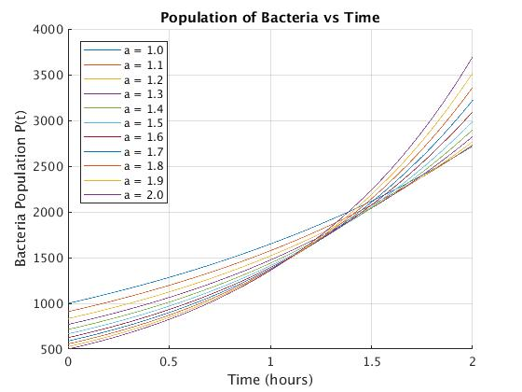

1. The greater the a value, the faster the increase of population. At any given time, for example, at 2 hours, the plot of $P(t) = \frac{1000}{a}e^{0.5at}$ where a = 2 has the greatest amount of bacteria while a = 1 has the least amount of bacteria.
2. The population where a = 2 grows the fastest as t → ∞. At t = 1.386, the population with a = 2 becomes the biggest population.

|  |  |  |  |
| --- | --- | --- | --- |
| a | Original Population | Doubling Time (From Graph) | Doubling Time (From Function) |
| 1.0 | 1000 | 1.386 | 1.3863 |
| 1.5 | 666.667 | 0.9238 | 0.92420 |
| 2.0 | 500 | 0.6934 | 0.69315 |

Yes, the doubling time found from the graph matches the doubling time found analytically using the function expression. The relationship between the doubling time and the ‘a’ value can be expressed as: $doubling time = \frac{1.386}{a}$. For example, $doubling time (a=1.5) = \frac{1.386}{a.5}=0.924$.

1. Similarities between doing matrix math by hand and through MatLab are that they both get the same results. Difference between doing matrix math by hand and through MatLab are that it’s much more accurate and faster to use MatLab for a great amount of matrix calculations, and that doing matrix math by hand has a higher chance of calculation mistakes, while by using MatLab, the main errors would be inputting the numbers wrong. Doing matrix math by hand is more appropriate than MatLab when MatLab is inaccessible or for doing matrix math for only one or two matrices. MatLab is more appropriate for doing a lot of matrix math or complex math. In addition, you can do matrix multiplication by hand, while on MatLab, for multiplication/division it multiplies/divides the components of the matrix to get the resulting component. Some important considerations engineers should consider when using “for” loops are what values the for loop should start and end (e.g. start at 1, end at 100 vs 1000), the number of iterations, what is repeated, and what value is incremented for the for loop.